**READ this procedure all the way through 3 times before starting!!**

**The following procedure was written for:**

1. Bing Carbs with the vacuum ports located on the bottom of the carb (most 40 mm).
2. OR 32 mm (and others) with the vacuum port on the side covered by a small screw with a fiber washer.
3. A homemade manometer, using ATF fluid and plastic tubing OR Carb Stix, Harmonizer, or Twin Max.

**THE PROCEDURE IS THE SAME NO MATTER WHAT INSTRUMENT YOU USE!!**

**Carburetor Adjustor and Vacuum Port Locations**

The pictures below show the locations of these parts on the 32 mm and 40 mm carburetors.

**32 mm Carburetors**

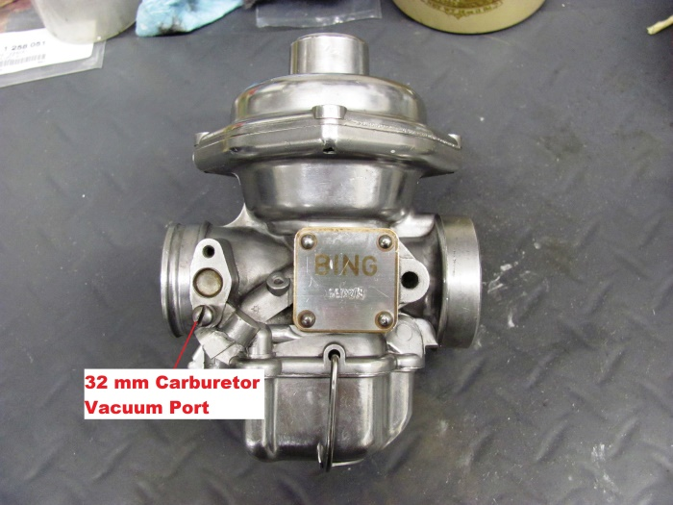 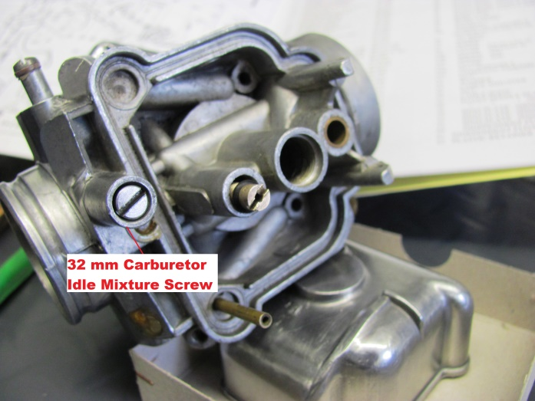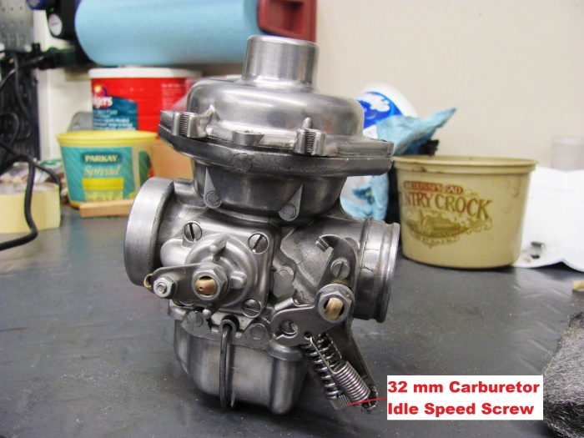

**40 mm Carburetors**

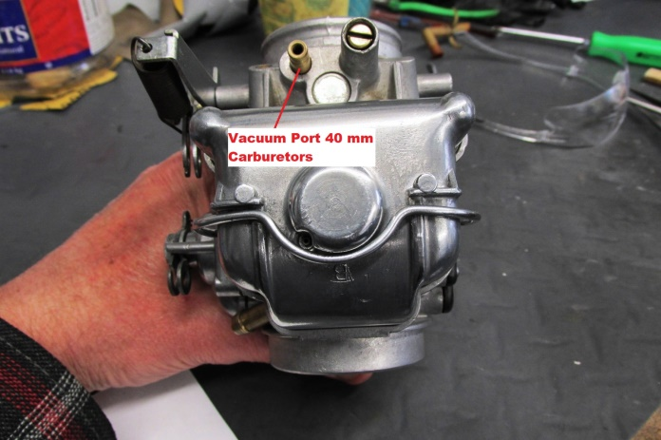 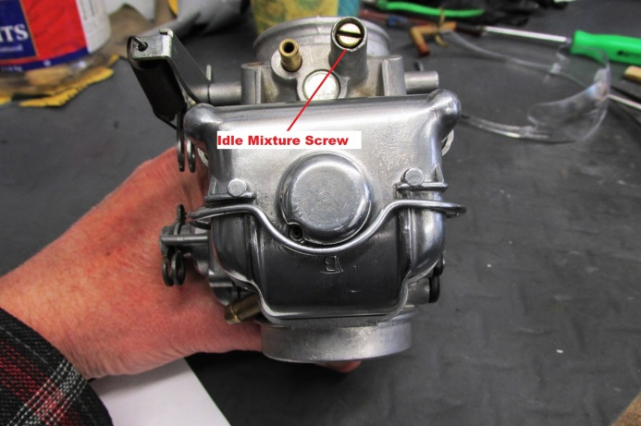

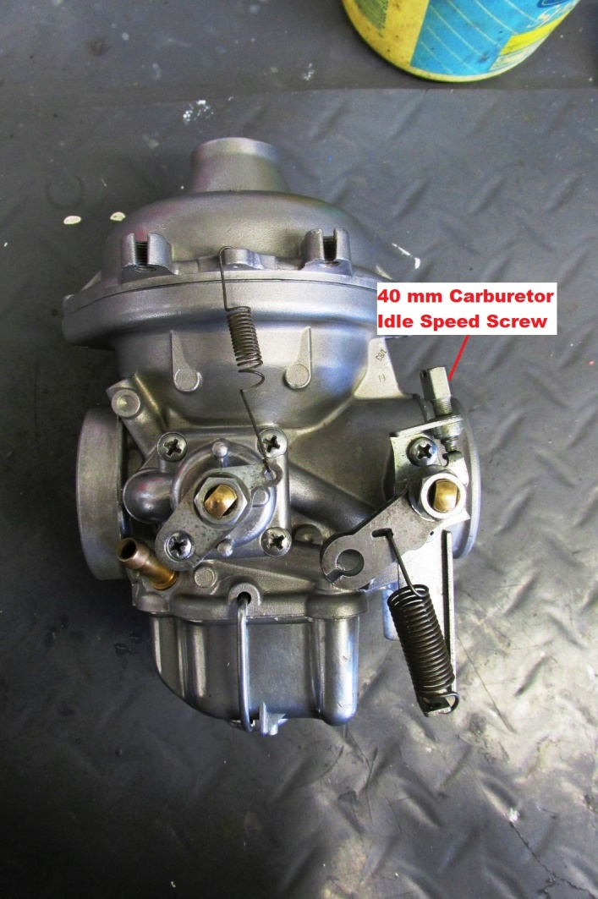

**Before You Start Carburetor Adjustments:**

**The valves MUST BE set correctly .006 (thousands) Intake & .008 (thousands) Exhaust! The timing set correctly, points (if equipped) gapped correctly, Carb float levels set correctly, Carb Needles in the correct position for your specific carbs, Chokes/Enrichers working properly full ON and OFF, etc.!! (You DO have a Bing Carb book Right? Check it for your carbs!)**

**IF these settings/adjustments are not correct the procedure below is useless to you!!**

**FINALLY - FAMILIARIZE yourself with location of the carb idle adjustment screws and the air/fuel mixture screws. DO NOT MIX THEM UP!!**

**NOTE:**

***Some folks suggest adjusting the air/fuel mixture BEFORE you attempt carb sync. If your machine was running before you started the major tune up it should start and run well enough to sync the carbs using this procedure. Adjusting the air/fuel mixture is best done as suggested below in this case, at Step #14.***

***IF you are starting from a fresh carb rebuild – then Start with the air/fuel mixture screws at the recommended settings for your carburetors. (See the Bing manual)***

**Adjustment Procedure**

1. **WARM THE BIKE** with about a 20-minute ride.
2. Place it on the center stand with a large fan in front of the jugs (don’t want to overheat the engine).
3. Make sure all the fittings on the intake and output of the carbs are tight with NO air leaks.

1. Set the cable slack on both carbs so that you have 2-4 mm (1/8 to 1/4 in) of slack on each. To check this, pull up on each cable and note how far the cable barrel comes out of the slack adjustment screw “seat”.
2. Loosen the 10 mm nut (may be 9 mm on some carbs) and screw the “slack” adjuster in or out to get 2-4 mm of slack - BEFORE you see the butterfly lever start to move as you lift the cable manually. Leave this nut loose for now!
3. Attach the Manometer to each vacuum port on the bottom (or side) of the carbs.
4. Start the bike and adjust the ***idle screws*** until the manometer fluid levels are equal WITH the idle about 1000-1100 rpm. The bike should idle smoothly when this is complete.
5. Raise the engine speed, with the throttle, to just off idle (1400-1800 rpm – (**butterflies barely open**). Note the balance of the fluid level in the manometer.
6. IF the right one is higher than the left, - - **TAKE UP** a tiny bit of slack in the **right** carb throttle cable adjustor,OR place **MORE** slack in the **left** throttle cable.
7. IF you are not sure about this, raise one of the throttle cables manually and watch the manometer fluid levels. This will tell you which way the adjustor needs to go! ***Less slack pulls more vacuum lowering the level in that side of the manometer.***

**NOTE:** **DO NOT** want to take up all the 2-4 mm of slack you started with in both cables!! **YOU NEED SOME SLACK IN BOTH CABLES WHEN DONE!**

1. This will take some “fiddling” to get the feel of it. The idea is to use the “slack adjustors” to make both cables pull the same vacuum when the throttle cables (butterflies) are opened **only** slightly. THAT is - with the butterflies open, just off idle.
2. IF the left side is higher, then either take up slack in the left side adjustor (pull more vacuum) OR add slack in the right-side adjustor (pull less vacuum).
3. **ONCE** this is set correctly and the manometer shows equal fluid levels at 1500-2000 rpm, raise the engine speed to about 4,000 rpm. The manometer should show equal “balance” on both sides. If not, make a TINY adjustment in the cable slack on one of the carbs (see steps 9 & 10 above).
4. **ONCE** you are satisfied with the ***throttle*** balance, find the air/fuel mixture screws on the bottom of the carb body. ***Number 7 on the Bing drawing.***

**NOTE: DO THE FOLLOWING ADJUSTMENT SLOWLY AS THE ENGINE NEEDS TIME TO ADJUST TO THE AIR/FUEL MIXTURE CHANGE.**

1. With the bike idling, on one carb (left or right) **SLOWLY** turn the air/fuel mixture screw Clockwise IN toward the body of the carb until the motor starts to stumble – **STOP** and note where the screw slot is relative to the carb body. Mark this with a felt tip marker for reference.
2. Back this same screw Counterclockwise OUT until the motor starts to stumble again (this is the opposite direction of step 15 above) – **STOP** and note where the screw slot is now, relative to the carb body. Mark this with a felt tip marker for reference.
3. Now move the air/fuel mixture screw to center it between these two markings.
4. Do this same procedure for the other carb!

**Turning the screw Clockwise (in/toward the body) results in a leaner mixture.   
  
Turning the screw Counterclockwise (out/away from the body) results in a richer mixture!!**

1. Note the readings on the manometer! ARE they still balanced? IF not, make a touch up adjustment with the throttle cable slack adjusters as mentioned above. **THIS WILL REQUIRE VERY LITTLE MOVEMENT if any! USE CAUTION HERE AND TAKE YOUR TIME!!! ☺**

**NOTE: Movement of the cable slack adjustors of 1 or 2 degrees of rotation will affect the adjustment. *Sometimes I hold the knurled screw with long nose pliers to keep it from moving while I tighten the lock nut.***

1. Raise the engine speed using the throttle and note if there is any hesitation as the engine speed is raised from idle to 2500-3000 rpm. This will transition the carburetors from operating using only the idle circuit, to the throttle circuit. Engine RPM should make a smooth transition with **NO** hesitation as the throttle is opened and engine speed picks up. **SHOULD** you have some hesitation or stumble, double check your settings! A slight adjustment of the air/fuel mixture screws will affect this.

**APPENDIX A: Using GROK Harmonizer**

[THIS IS PROVIDED BY KATDASH WHO NOW HAS THE RIGHTS TO THE ORIGINAL GROK HARMONIZER © Kat Dash]

The original GROK Harmonizer is now manufactured by Katdash. Here is a link to the instructions on how to use it to balance your carburetors.

* [Airhead Tuning With GROK Harmonizer](http://katdash.com/wp-content/uploads/2020/02/Harmonizer-Bing_CV.pdf)

Below are some pictures of the Harmonizer to help you understand the text.

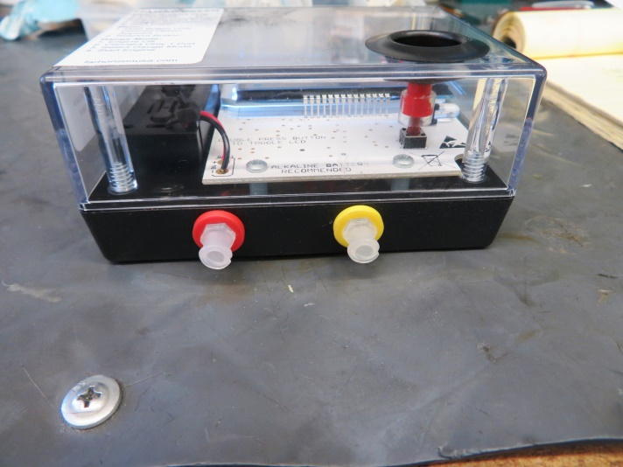 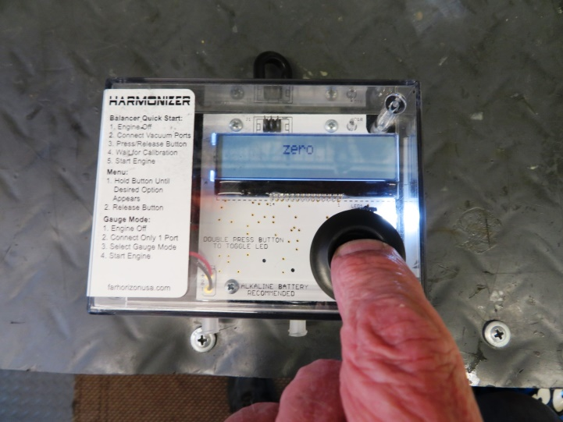

***Harmonizer Box With RED & YELLOW Ports Zero Mode***

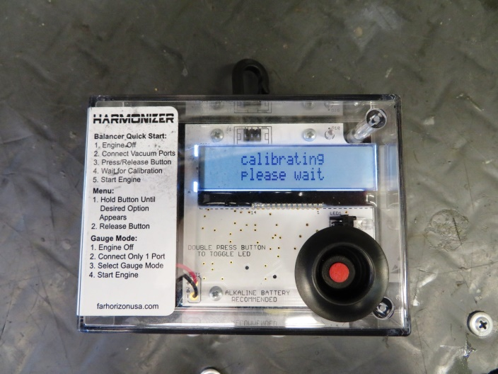 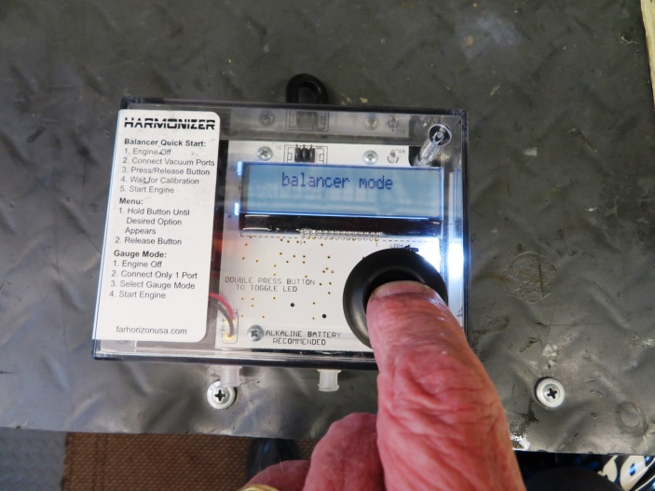

***Calibrate Mode Balancer Mode***

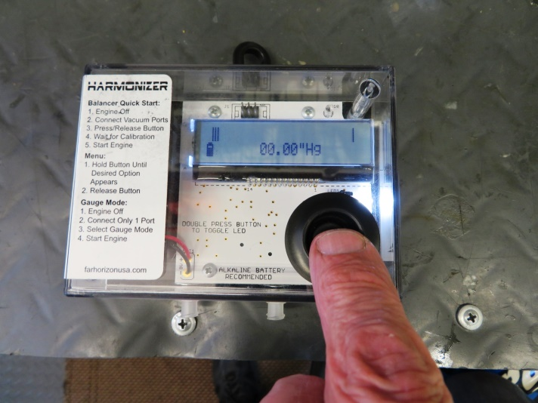 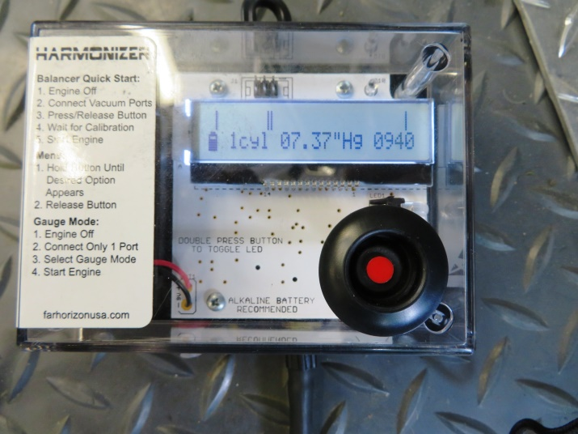

***Gauge Mode Adjust For Highest Vacuum In Gauge Mode***