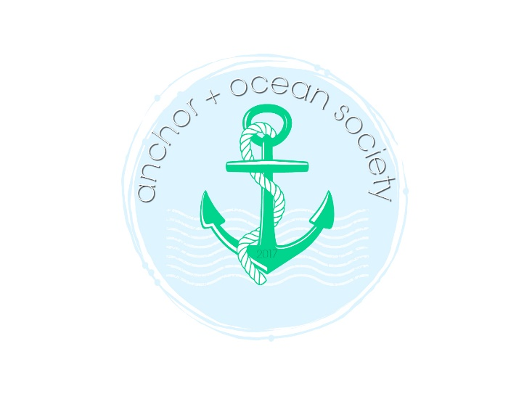

www.anchorandocean.com
anchorandoceansociety@gmail.com

