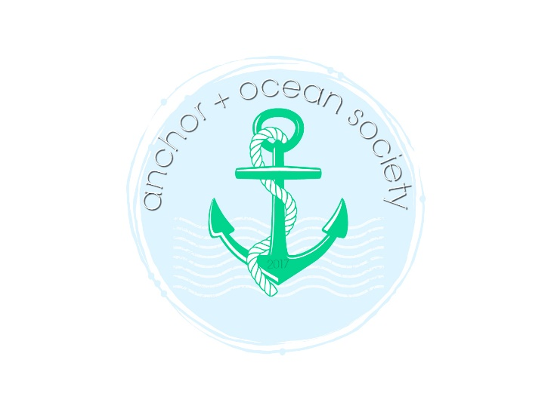

2021/2022 Season: Medfield Outreach $3,110

2020/2021 Season: 826 Boston $2,100

2019/2020 Season: OneSight $800

Volunteer/Item Donations:
- The Home for Little Wanderers
- Medfield Parks & Recreation Department
- Concord Park, a Volunteers of America Assisted Living Facility
- Cradles to Crayons
- U.S. Military

www.anchorandocean.com
anchorandoceansociety@gmail.com

